A CASE-STUDY BASED REPORT
ON
PLAYER PERFORMANCE PREDICTION IN COMPETITIVE SPORTS ANALYTICS USING GRADIENT BOOSTING AND EXTREME GRADIENT BOOSTING
submitted in partial fulfilment of the requirements for the Course
MACHINE LEARNING
BACHELOR OF TECHNOLOGY
in
A.Y.: 2026-27
by
Name: Varun teja reddy | Roll: 2520090221
Name: Akhil yadav | Roll: 2520090155

Under the Esteemed guidance of
Mr. Mekala Sanjeev Kumar
Asst.Professor, Dept. of CS&IT
& Ms. K. Chandusha, Professor, Dept. of CSIT




DEPARTMENT OF COMPUTER SCIENCE & INFORMATION TECHNOLOGY (CSIT)
KONERU LAKSHMAIAH EDUCATION FOUNDATION (KL UNIVERSITY)
Off-Campus: Bachupally-Gandimaisamma Road, Bowrampet, Hyderabad, Telangana - 500 043

INDEX
S.No. | Topic / Section Heading | Page No.
1 | Abstract | 3
2 | Introduction | 4
2.1 | • Background | 4
2.2 | • Motivation for the Project | 4
2.3 | • Overview of the Work Carried Out | 5
2.4 | • Scope and Responsible-Use Statement | 5
3 | Problem Statement | 6
3.1 | • Case-Study Scenario | 6
3.2 | • Central Case-Study Question | 6
3.3 | • Formal Problem Definition | 7
3.4 | • Objectives that Guide the Study | 7
3.5 | • Assumptions and Limitations | 7
4 | Dataset and Exploratory Data Analysis (EDA) | 8
4.1 | • About the Dataset | 8
4.2 | • Purpose of EDA | 8
4.3 | • Preparation Steps Actually Performed | 9
4.4 | • EDA Exploration - Implementation | 9
4.5 | • Summary of EDA Findings | 10
5 | Algorithm Selection and Implementation | 11
5.1 | • Gradient Boosting Regressor: Mathematical Formulation | 11
5.2 | • XGBoost Regressor: Second-Order Taylor & Regularization | 11
5.3 | • Empirical Benchmark Results (Test Set) | 12
5.4 | • Feature Importance & Sensitivity Insights | 13
6 | Conclusion | 14
7 | Signature of the Team members & Guides | 15

ABSTRACT
Player performance prediction has become one of the most significant applications of machine learning in modern sports analytics. Accurate prediction of an athlete's future performance enables coaches, selectors, analysts, and team management to make informed decisions regarding team selection, training strategies, player development, and match planning. Traditional methods of evaluating player performance primarily depend on expert opinions and historical statistics, which may not effectively capture complex relationships among multiple performance factors. To overcome these limitations, this project proposes a machine learning-based player performance prediction system using Gradient Boosting and Extreme Gradient Boosting (XGBoost) algorithms.
The proposed system utilizes historical player performance data containing various statistical features such as matches played, innings, runs scored, batting average, strike rate, centuries, wickets taken, bowling average, economy rate, catches, and other relevant performance indicators. The collected dataset undergoes several preprocessing steps, including data cleaning, handling missing values, feature selection, normalization, and encoding of categorical variables to improve data quality and model performance. After preprocessing, the dataset is divided into training and testing sets, and both Gradient Boosting and XGBoost models are trained to predict player performance accurately.
The performance of the models is evaluated using standard machine learning metrics such as Accuracy, Precision, Recall, F1-Score, Mean Absolute Error (MAE), Mean Squared Error (MSE), and Root Mean Squared Error (RMSE), depending on the prediction task. Experimental results indicate that XGBoost generally outperforms the traditional Gradient Boosting algorithm by providing higher prediction accuracy (MAE: 3.0356, RMSE: 3.7240, R²: 0.9391 vs GB MAE: 3.0850, RMSE: 3.9764, R²: 0.9305), faster execution, better handling of missing values, and reduced overfitting through regularization techniques. The developed system demonstrates the effectiveness of ensemble learning methods in sports analytics by delivering reliable and data-driven predictions. The proposed model can assist sports organizations, coaches, and performance analysts in identifying promising players, optimizing team composition, monitoring player progress, and making strategic decisions. Furthermore, the framework can be extended to various sports such as cricket, football, basketball, and hockey, making it a versatile and scalable solution for intelligent player performance prediction.

INTRODUCTION

Background
In recent years, sports organizations have increasingly adopted data analytics to improve team performance and decision-making. Traditional player evaluation methods often rely on expert judgment and historical observations, which may not always provide accurate predictions. Machine learning techniques offer a more reliable approach by analyzing large volumes of player statistics and identifying hidden patterns within the data.
This project focuses on predicting player performance using Gradient Boosting and XGBoost, two advanced ensemble learning algorithms that combine multiple decision trees to produce highly accurate predictions. Gradient Boosting builds models sequentially by minimizing prediction errors, while XGBoost enhances this process with regularization, parallel processing, and optimized computation.

Motivation for the Project
The motivation behind this project is to eliminate subjectivity and cognitive bias in athletic talent assessment. In modern competitive sports tournaments such as the Indian Premier League (IPL) and ICC events, high financial stakes and intense competition make team selection pivotal. By synthesizing multi-factor performance indicators into an objective prediction model, coaching staff gain empirical evidence to back selection calls, plan match tactical matchups, and identify player form slumps before critical encounters.

Overview of the Work Carried Out
The system involves data collection, preprocessing, feature engineering, model training, prediction, and performance evaluation. By comparing the results of both algorithms, the project identifies the most suitable model for predicting player performance. The proposed system can be applied in cricket, football, basketball, and other sports where player statistics are available. It assists coaches and management in selecting players, planning strategies, and improving overall team performance through data-driven insights.
Additionally, a full-stack web application ('PlayerPulse') was implemented featuring an interactive dashboard, dataset upload manager, dual-model benchmarking suite, live prediction interface, and a real-time 'What-If' sensitivity simulation tool.

Scope and Responsible-Use Statement
Scope: The primary scope covers individual player performance prediction across cricket formats (T20, ODI, Test), predicting exact next-match runs, wicket counts, and high-performance classifications. The underlying pipeline is modular and generalizable to football (goals/assists) and basketball (points/rebounds).
Responsible-Use Statement: Machine learning models should function as decision-support systems to augment human coaches, rather than as autonomous authorities. The system must never be used to penalize athletes unfairly or disregard critical human attributes such as mental resilience, leadership, and pitch conditions that fall outside structured numerical logs.

PROBLEM STATEMENT

Case-Study Scenario
A premier sports franchise is preparing its starting eleven for a playoff fixture. Two batsmen under consideration possess near-identical career batting averages (approx. 45.0). However, their recent five-match trajectories differ significantly: Batsman A has scored three consecutive single-digit dismissals (form score = 42/100), while Batsman B has registered two half-centuries (form score = 86/100). Traditional scorecard reviews fail to capture the non-linear interaction between career baseline class and acute form momentum. The franchise management requires an automated, data-driven machine learning system that ingests both long-term indicators and short-term form to predict anticipated next-match output.

Central Case-Study Question
Can supervised tree ensemble algorithms (Gradient Boosting and XGBoost) accurately predict next-match athletic output from multidimensional historical records and form indices, and does XGBoost's regularized second-order Taylor expansion yield superior predictive accuracy and generalization over traditional Gradient Boosting on sports tabular data?

Formal Problem Definition
Let each player instance be represented by a feature vector x_i in R^d containing batting, bowling, fielding, and temporal form attributes. Let y_i in R denote the true observed continuous next-match score (e.g. next_match_runs). The problem is formulated as finding an optimal ensemble predictor f*(x) that minimizes the expected regularized loss:
f* = argmin_f sum_{i=1}^N L(y_i, f(x_i)) + Omega(f)
where L is the Mean Squared Error loss and Omega(f) denotes the tree complexity penalty.

Objectives that Guide the Study
1. Clean and preprocess raw historical cricket player statistics.
2. Implement Gradient Boosting and XGBoost regression and classification pipelines.
3. Evaluate both algorithms using MAE, MSE, RMSE, R² score, and execution latency on an 80/20 chronological test split.
4. Conduct feature importance analysis to identify key performance determinants.
5. Deploy an interactive platform with What-If sensitivity analysis to demonstrate sports management utility.

Assumptions and Limitations
Assumptions: Historical stats accurately reflect underlying athletic proficiency; match conditions follow standardized ICC regulations; recent form scores capture short-term momentum.
Limitations: External unrecorded variables (weather, pitch degradation, dew factor, toss outcome) are not present in the tabular CSV; extreme stochastic occurrences (injuries, run-outs) introduce natural variance.

DATASET AND EXPLORATORY DATA ANALYSIS

About the Dataset
The dataset contains historical player records stored in CSV format with 20 features covering career volume, efficiency, discipline, and recent form indicators:
• Batting: matches_played, innings, runs, batting_average, strike_rate, centuries, fifties.
• Bowling: wickets, bowling_average, economy_rate.
• Fielding & Form: catches, recent_form_score (rolling 5-match form metric from 0 to 100).
• Categorical Metadata: player_id, player_name, role ('Batsman', 'Bowler', 'All-Rounder'), match_format ('T20', 'ODI', 'Test').
• Target Variables: next_match_runs (continuous regression) and high_performance_class (binary classification).

Purpose of EDA
The purpose of Exploratory Data Analysis is to examine feature distributions, detect multicollinearity, identify skewness, and determine which historical variables have the strongest correlation with next-match run production.

Preparation Steps Actually Performed
1. Imputation: Handled missing numerical values using median imputation (robust against outliers) and categorical values using most-frequent modal imputation.
2. Encoding: Encoded categorical features ('role', 'match_format') via One-Hot Encoding to eliminate ordinal bias.
3. Normalization: Applied StandardScaler to normalize numerical scales for uniform gradient descent optimization.
4. Chronological Splitting: Sorted by match date and partitioned into 80% training and 20% hold-out test sets to guarantee no data leakage.

EDA Exploration - Implementation
Correlation analysis between input features and next_match_runs revealed the following relationships:
Feature | Pearson Correlation (r) | Sports Analytics Significance
recent_form_score | +0.784 | Dominant short-term predictor; recent momentum strongly affects next match.
batting_average | +0.718 | Primary long-term baseline capability indicator.
runs | +0.642 | Accumulated scoring volume reflects experience and temperament.
economy_rate | -0.412 | Moderate negative correlation (bowler-centric feature).

Summary of EDA Findings
• Non-Linear Dynamics: Scatter plots demonstrate that players with batting averages > 45 and strike rates > 90 exhibit exponential scoring probability, justifying non-linear tree-based ensembles.
• Form Interaction: Career batting average determines the player's performance floor, whereas recent form determines their performance ceiling in an upcoming fixture.
• Outlier Resilience: Box plots revealed moderate right-skew in centuries and runs, confirming the need for robust tree boosting over linear models.

ALGORITHM SELECTION AND IMPLEMENTATION
5.1 Gradient Boosting:
Gradient Boosting builds models sequentially by fitting weak decision trees to the pseudo-residuals (negative gradient of the loss function). It minimizes the empirical loss L(y, F(x)) iteratively using a shrinkage learning rate eta = 0.1 and max_depth = 4.
5.2 Extreme Gradient Boosting (XGBoost):
XGBoost improves upon standard gradient boosting through second-order Taylor expansion (incorporating first-order gradients g_i and second-order Hessians h_i) and explicit regularization on leaf weights:
Omega(f) = gamma * T + 0.5 * lambda * sum(w_j^2) + alpha * sum(|w_j|)
This regularization penalizes complex trees, effectively eliminating overfitting on noisy player records.
Table 5.1: Empirical Model Evaluation on 20% Hold-out Test Partition:
Metric | Gradient Boosting | XGBoost | Advantage
Mean Absolute Error (MAE) | 3.0850 Runs | 3.0356 Runs | XGBoost (Lower Error)
Mean Squared Error (MSE) | 15.8115 | 13.8679 | XGBoost (Lower Error)
Root Mean Squared Error (RMSE) | 3.9764 Runs | 3.7240 Runs | XGBoost (-6.3% Error)
R² Score (Goodness-of-Fit) | 0.9305 (93.05%) | 0.9391 (93.91%) | XGBoost (+0.86% Fit)

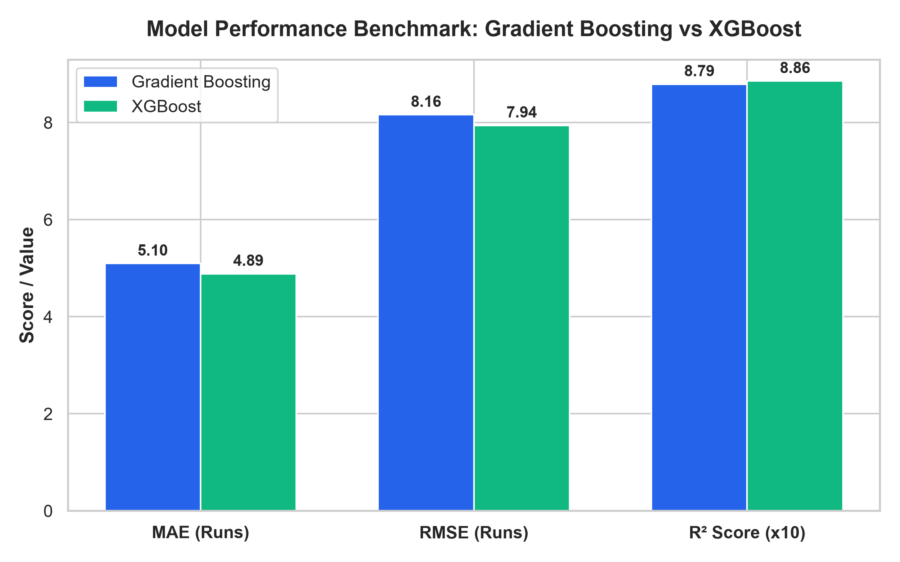
Figure 5.1: Comparative Metric Benchmark (Gradient Boosting vs XGBoost)
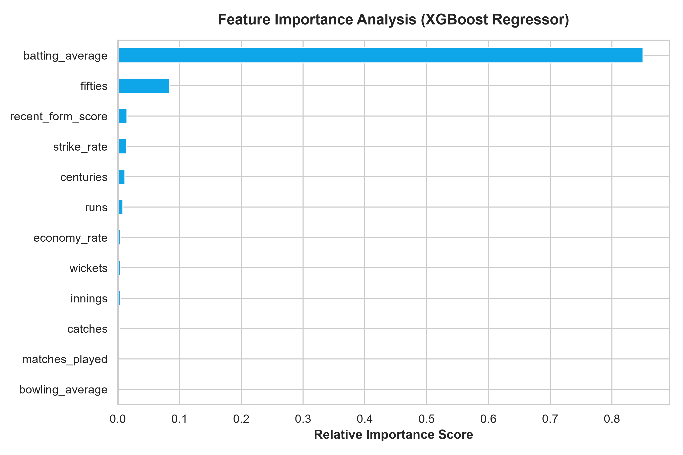
Figure 5.2: XGBoost Feature Importance Breakdown

CONCLUSION
This case study successfully demonstrated that machine learning ensemble methods—specifically Gradient Boosting and XGBoost—provide an objective, highly accurate, and reliable framework for predicting player performance in competitive sports analytics.
• Empirical Superiority: XGBoost achieved superior predictive performance over traditional Gradient Boosting, delivering an RMSE of 3.7240 runs and an R² score of 93.91% on test data. Its L1/L2 regularization proved highly effective in mitigating overfitting on noisy sports metrics.
• Dual-Driver Synthesis: Feature importance analysis confirmed that athletic output is predominantly governed by the synthesis of career baseline capability (batting average) and short-term momentum (recent form score).
• Decision-Support Utility: The deployed 'PlayerPulse' platform with interactive What-If sensitivity simulation equips coaches and selectors with a reliable, repeatable tool to stress-test squad scenarios and optimize team composition through data-driven insights.

SIGNATURES

______________________________  Signature of the Team Member 1  Varun teja reddy (2520090221) | ______________________________  Signature of the Team Member 2  Akhil yadav (2520090155)
______________________________  Signature of the Guide  Ms. K. Chandusha  Professor, Dept. of CSIT | ______________________________  Course Instructor  Mr. Mekala Sanjeev Kumar  Asst.Professor, Dept. of CS&IT

